Extension materials for lecture 4 : Radiotherapy

The Start of Radiotherapy

- Nov 8th 1895, Willhelm Röntgen first discovers x-rays by chance, whilst playing with several new types of vacuum tube apparatus
- In 1896 within a year of the discovery, x-rays were being used for treatment of skin metastases
- This close integration with physics based technologies has remained in radiotherapy, particularly now in the time of image guided radiotherapy, proton beam radiotherapy, and computerised treatment planning.
- There have been two threats to the public perception of radiotherapy. The first was after the atomic bomb droppings at the end of World War II, and the second during the 1980’s when survivors of breast cancer radiotherapy protested about the late side effects of radiotherapy (particularly brachial plexus neuropathy) using the equipment of that era (Radiation Action Group Exposure, RAGE)

Remember your physics : There is no difference between an x-ray and a gamma-ray. An x-ray is electrically generated, whilst a gamma-ray is emitted from a naturally radioactive material.

The age of radiotherapy
- Radiotherapy is now a safe and highly effective form of cancer therapy, which is rapidly integrating new technological developments into clinical practice. Laser scanning, robotics, machine learning AI, in-room GPS and nanomaterials are some of the technologies that are now available in radiotherapy products.
- Industry reviews now suggest the average lead time for development of new technology and integration into a radiotherapy product is now 5-7 years.
- It takes 12-15 years to get a new drug from discovery stage into widespread clinical use
- 2011 was promoted as the year of radiotherapy by the National Cancer Action team. From roadshows to Eastenders stories, it represented a major push by government to illustrate the importance of radiotherapy in cancer care.

Different types of radiotherapy
- Most of the radiotherapy that we give is classed as teletherapy, which means that the source of the radiation is outside (and some distance from) the patient. We use linear accelerators (Linacs) to generate x-rays electrically, by accelerating electrons and smashing them into a tungsten target.
- All linacs work on the same principal, but there are some specialized machines whose names you might hear

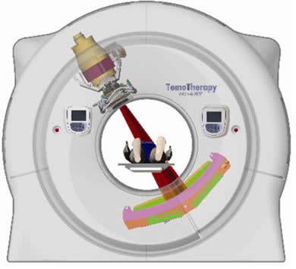  The TomoTherapy unit has geometry like traditional CT scanner: radiation beam rotates round the patient as they move through the machine | 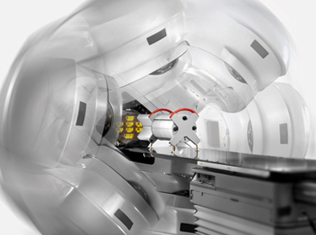  VMAT or volumetric modulated arc therapy, uses a traditional linear accelerator gantry rotating round the patient | 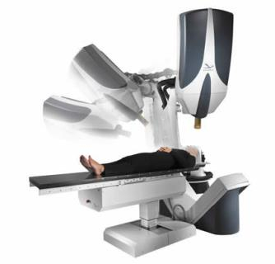  Cyberknife uses linear accelerator mounted on end of a robotic arm: moves around patient with high number of degrees of freedom

- Brachytherapy refers to the use of radiation sources that are placed either within or on the surface of the patient. They are used in gynecology and prostate cancer treatment. They rely on the principle of the inverse square law, whish states that radiation flux(dose) falls with the square of distance from the surface of the source. By placing the radiation source close to the tumour, high doses can be delivered whilst maintaining low doses to the surrounding health organs.
- Isotope therapy uses radioactive isotopes that are injected into the blood stream and localize to the area of a tumour. This can be done in a variety of ways:
  - Radioiodine. We are very fortunate that apart from the salivary glands, iodine is mostly absorbed by the thyroid gland. This means that radioactive iiodine can be used to ablate part of the thyroid gland in thyrotoxicosis, or to destroy remnant thyroid tissue post thyroidectomy in thyroid cancer.
  - Radioimmunotherapy. I-131 labelled rituximab binds to CD20 receptors expressed on B cells in B cell lymphoma
  - Sirtex. Selective internal radiation therapy. These are small radioactive beads injected into the hepatic artery to treat primary liver tumours and metastatic liver cancer.

Increasing conformality of radiotherapy

- A good deal of the technical development in radiation therapy has been around conforming the radiation beam to the shape of the tumour
- In the early days of radiotherapy, and before the advent of cross sectional imaging, treatment was calculated in 2 dimensions, taking an outline of the patient or a radiograph and getting the clinician to draw on the target. A set of radiation beams would be chosen to cover the radiation target. The plans looked like this treatment for a prostate cancer:

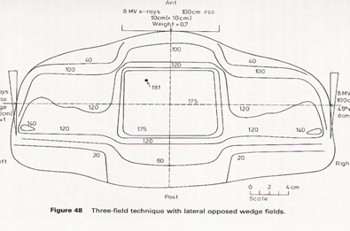
- With the advent of CT scanning, we were able to visualise the tumour target and surrounding normal tissue structures. Instead of using square x-ray beams, lead blocks or other beam shaping devices were used to shape the beam to fit the shape of the tumour. This simple measure means that 40% less healthy normal tissue is treated. The picture below shows a multi-leaf collimator – device that sits in the head of the machine which can move leaves of lead in and out of the beam, to ‘shape’ the beam to match the target:

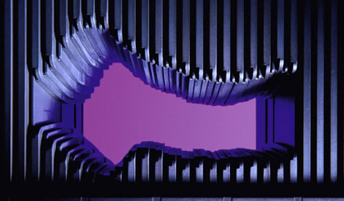

- Intensity modulated radiotherapy takes a different approach to shaping the radiation to the target. Each beam is broken up into little ‘beamlets’, each of which can be turned on or off individually to deliver varying levels of dose. Using multiple beams coming from different directions, it is possible to build up a complex distribution of radiation dose. In the colour wash image below, the high dose is in red, and you can see how tightly it matches the shape of the target
- Finally, image guided radiotherapy is the current ‘state of the art’ in x-ray based radiotherapy. It is not really about increasingly conformal shaping of the radiation beam, but rather looks at the issue of positional accuracy. After all there is no point in having a beautifully shaped radiation field if you are 2cm off target. In image guided radiotherapy, some form of imaging, usually a CT scan, is obtained with the patient lying in the treatment position, and the scan is used to ensure that the radiation is correctly targeted at the tumour. It’s much easier to see than to explain, and there is a great 90 second youtube video available here that goes through the process: https://www.youtube.com/watch?v=bBpEkIIRqpk

Tims and dose effects in radiotherapy fractionation

- Most radiotherapy treatment is broken up into small treatments, called fractions, rather than being given in one go. There is a good biological reason for this. Defective DNA repair is a common feature of cancer cells, but not healthy tissue cells. The repair half time for DNA damage in most mammalian cells is about 8 hours. Let’s consider what happens if we irradiate a tumour and have some way to quantify the DNA damage at any point in time:
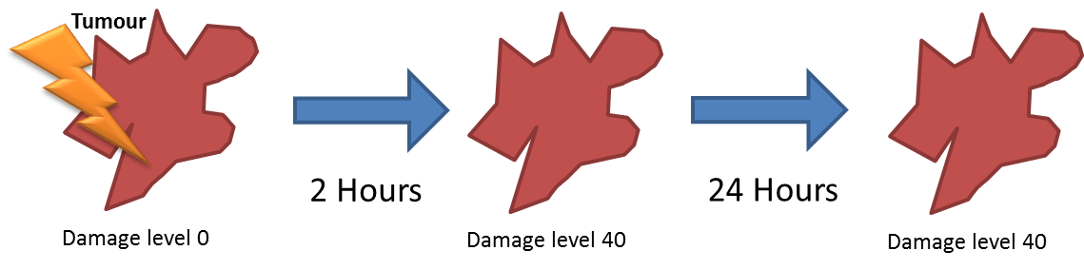

- Before radiotherapy the tumour damage level is 0, After RT the damage level is 40 and it stays at 40 24 hours after radiotherapy when the next dose is due
- Now let’s consider a healthy cell in the same way:

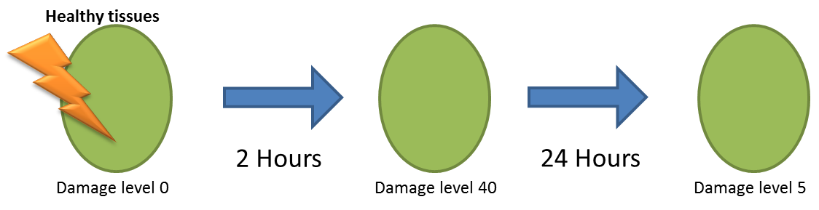

- The healthy cell has the same dose of radiotherapy so sustains the same DNA damage at 2 hours post iorradiation, but by 24 hours, 3 DNA repair half times have passed to the damage level has halved, halved, and halved again.

Proton beam therapy

- IMRT delivers wonderful radiotherapy plans that shape the radiation dose to the target. As we use more and more beamlets of radiation to target the tumour, we can ‘paint’ dose with higher spatial precision
- The cost of this is smearing more low dose radiation through the patient. Look at all the light blue and dark blue on this dose colour wash, representing healthy tissue receiving a low dose:

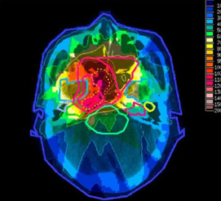

- Low doses may be important in late effects of radiotherapy, especially in growing children.
- Proton beam therapy works in a different way to x-ray radiotherapy. It uses highly energetic protons travelling near the speed of light. The rate at which they deposit energy is dependent on their speed. When they first hit the patient, they are travelling too fast to deposit much dose. Then they slow down in tissue, until they slow down and stop, releasing all of their rest mass energy in a big lump, known as the Bragg peak. By tuning the energy of the beam to the depth of the tumour target, we can produce radiotherapy plans with no exit dose after the beam has hit the target, rather than low exit dose as found in x-ray radiotherapy.
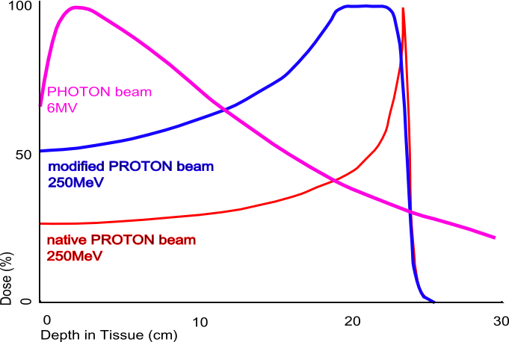

- Currently we only have a low energy proton therapy unit in UK for treating eye tumours
- Two clinical facilities are being developed in UCL and Manchester for 2018 and 2019 respectively.
- An x-ray based linac unit costs about £1.2-4M
- A proton therapy facility costs around £40-£100M
- Until then we have a system in place for treating NHS patients in Switzerland and the USA
- If you look at the same case treated with proton beam therapy, you can see that the Dose conformity to the tumour is similar in both plans, but there is much less low dose bath with the proton plan: cerebellum & posterior neck tissues receive no dose

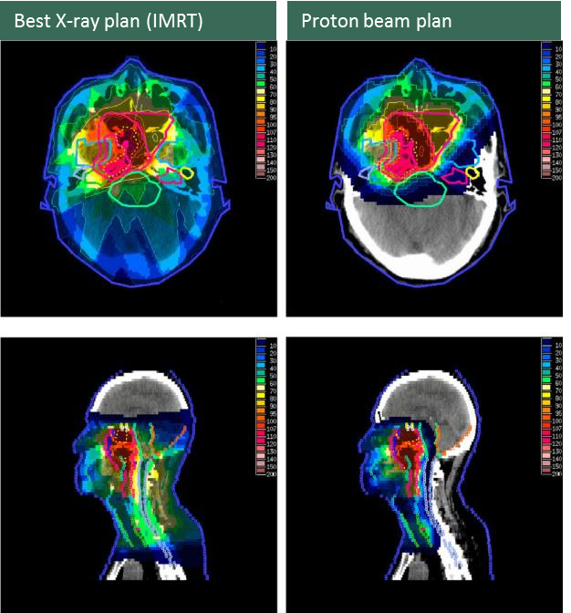

- There are some downsides to PBT though. The techniques we have developed for image guided x-ray radiotherapy don’t work for proton beam therapy, as there is no dose emerging out of the patient that we can measure.
- Also there are biological differences between 1Gy os x-ray dose an 1Gy of proton beam dose. The biological effects of protons are complex and not fully characterized.

